**Week1**

**1. Spark?**

Similar with MapReduce, but run in memory

1.1 features

Speed/ powerful caching/ deployment/ real-time/ multilanguages

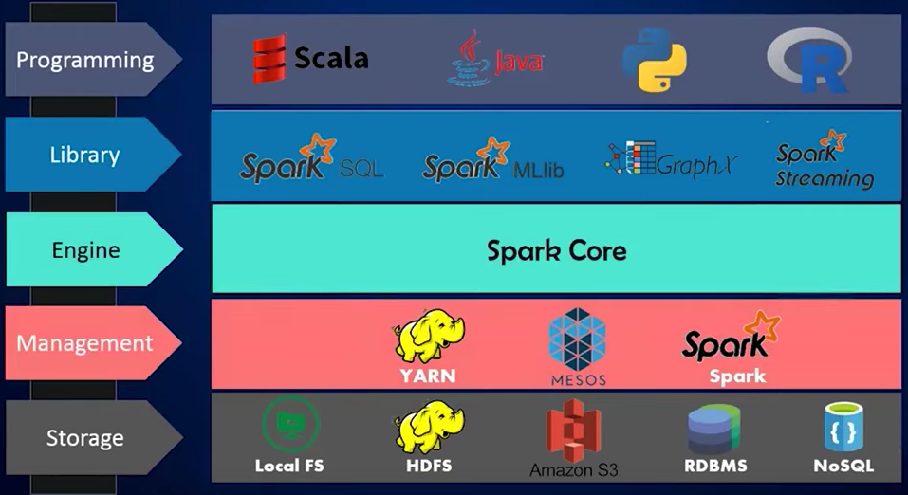

1.2 Setup

* The easiest way to run SBT commands from from IntelliJ IDEA is to use the Terminal tool window via option+fn+F12

**2 From Parallel to Distributed**

**2.1 You’ll learn…**

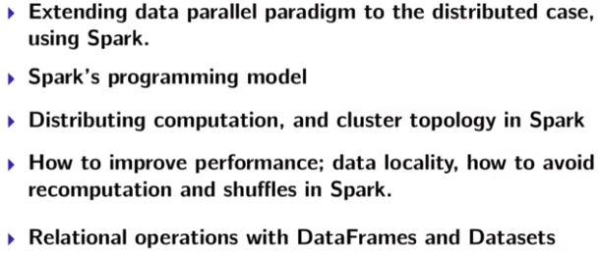

**2.2 Data-Parallel to Distributed Data-Parallel**

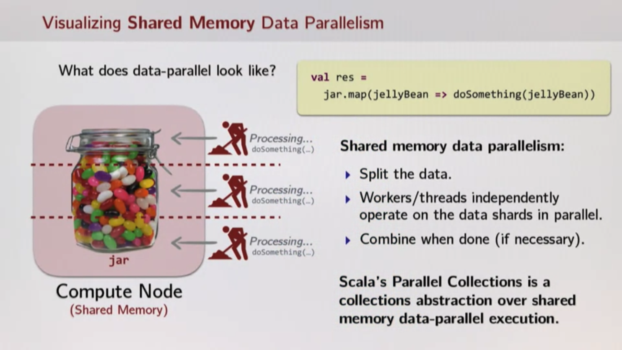

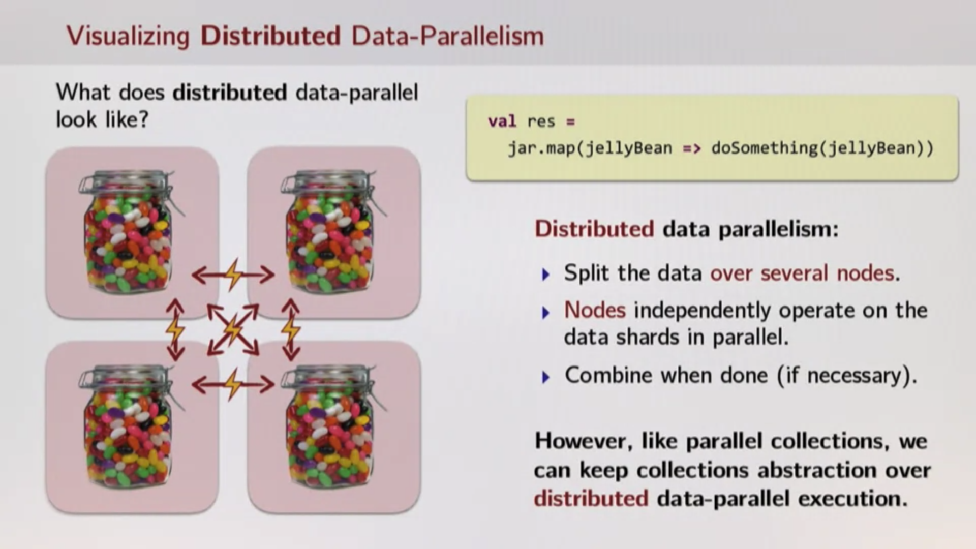

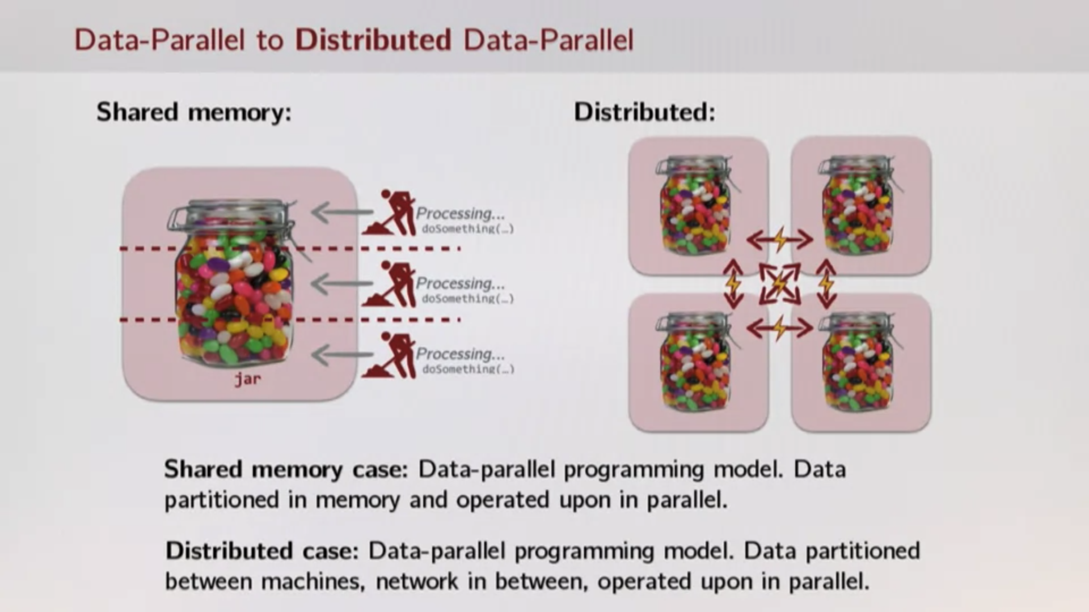

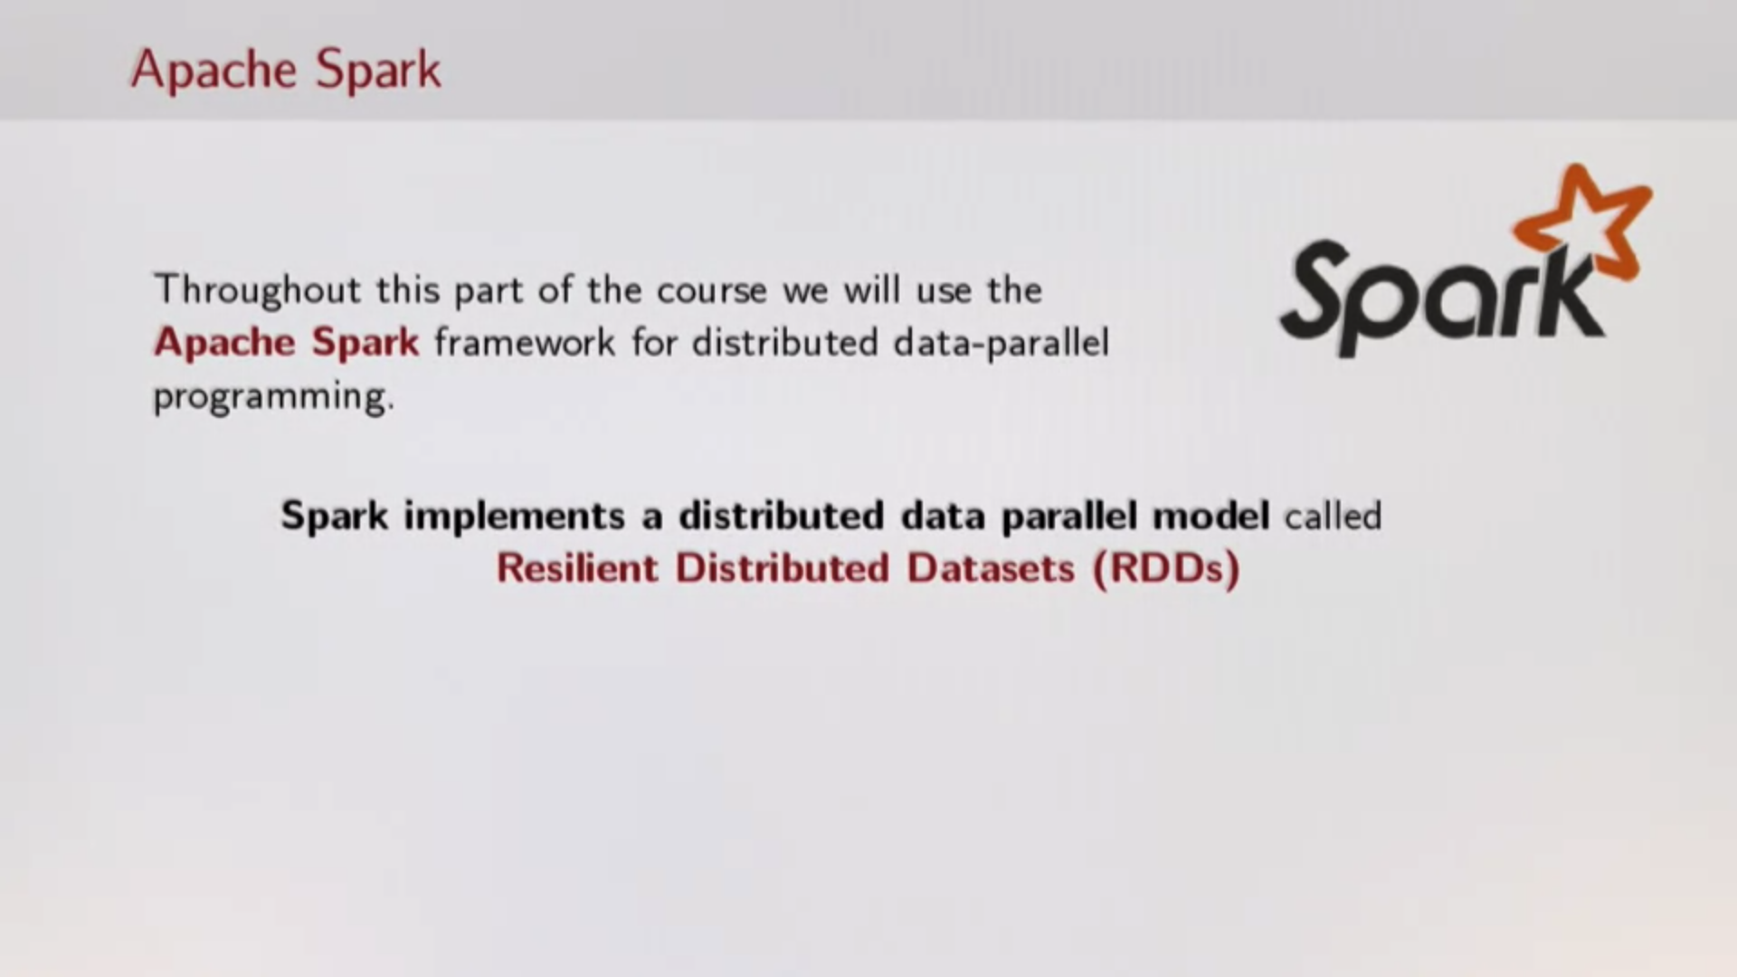

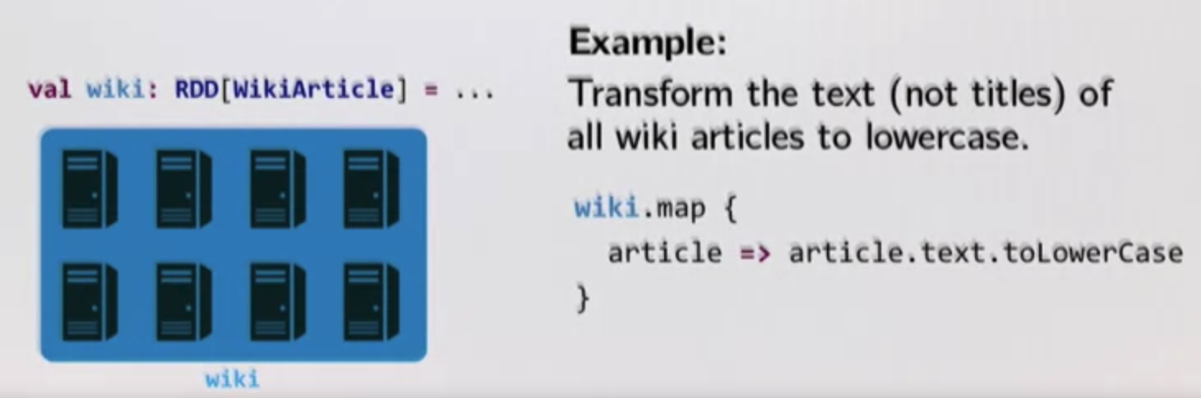

**2.3 Latency**

Data parallelism on a single machine —> Data parallelism in a distributed setting

Distributed collections abstraction from Apache Spark as an implementation of this paradigm.

Concern:

* Partial failure: crash failures of a subset of the machines involved in a distributed computation
* **Latency**: certain operations have a much higher latency than other operations due to network communication -> always want to reduce the amount of communication

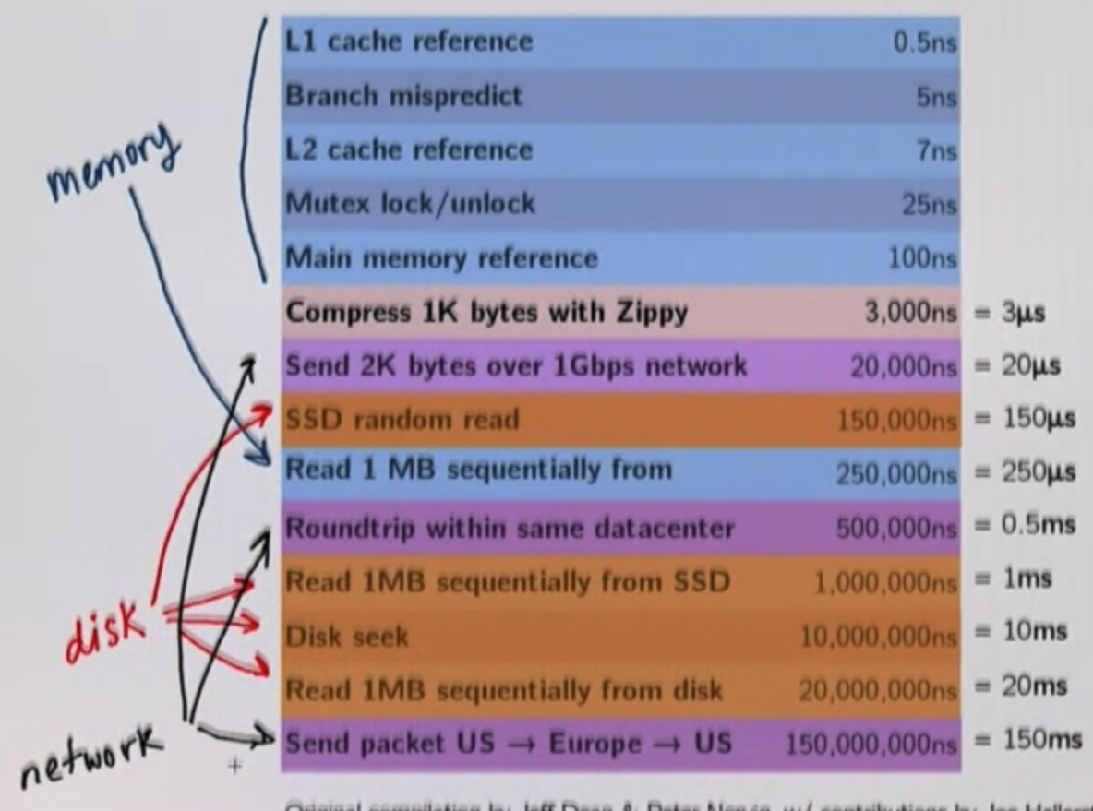

memory

Hadoop: Spark’s predecessor

MapReduce is first used by Google, provides simple APIs (simple map and reduce steps) and fault tolerance is what made it possible for Hadoop/MapReduce to scale to 100s or 1000s of nodes at all

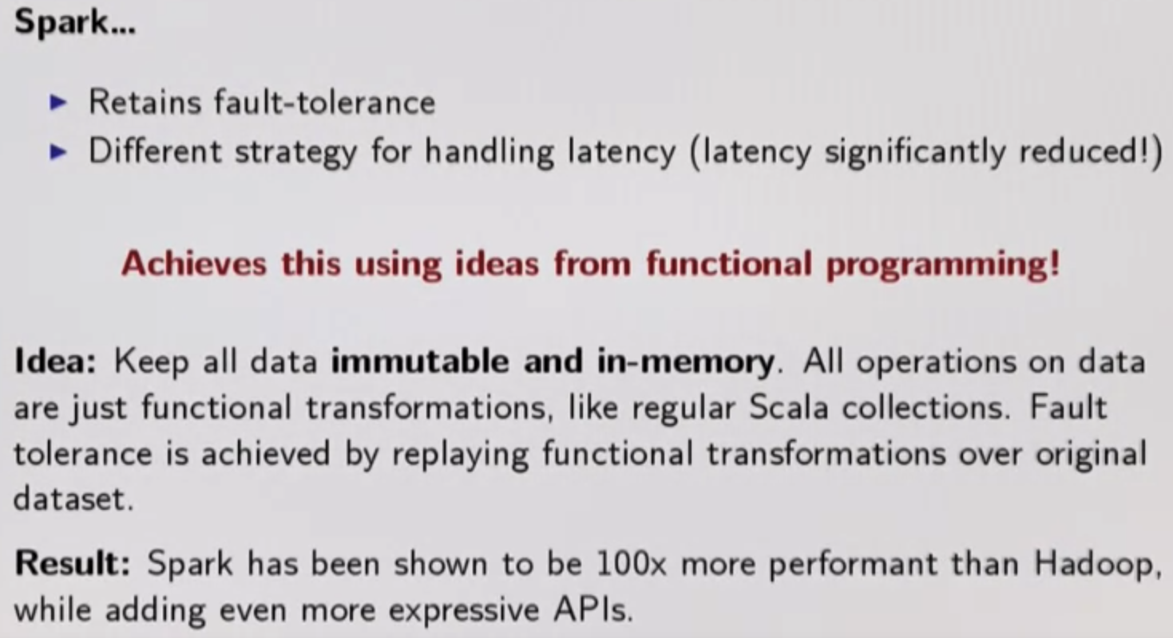

* Hadoop doing a lot Disk + Network
* Spark doing a lot Memory + Network —> (aggressively minimize Network traffic, shift to intermemory)

**3 Basics of Spark's RDDs**

**3.1 RDDs, Spark's Distributed Collection**

Resilient Distributed Datasets (RDDs), Spark’s Distributed Collections

Combinators on RDDs (also on Scala parallel/sequential collections):map, flatmap, filter, reduce, fold, aggregate

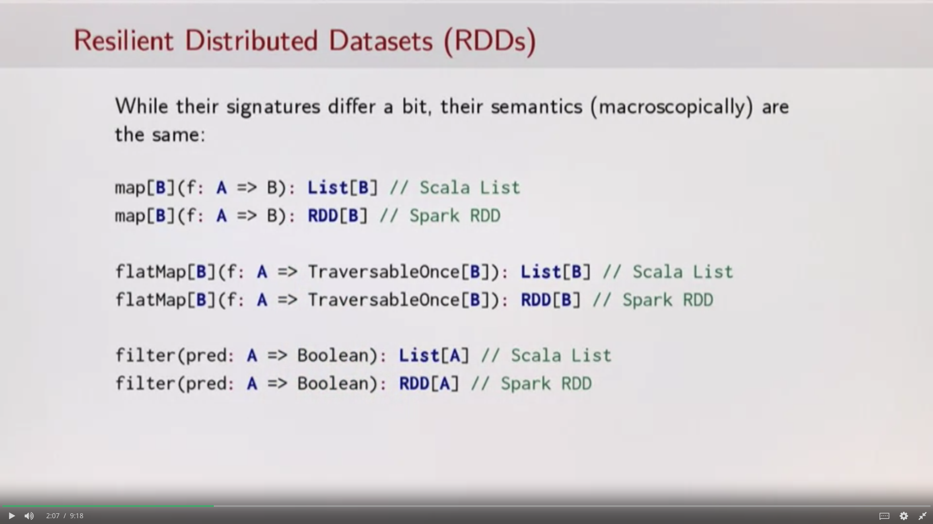

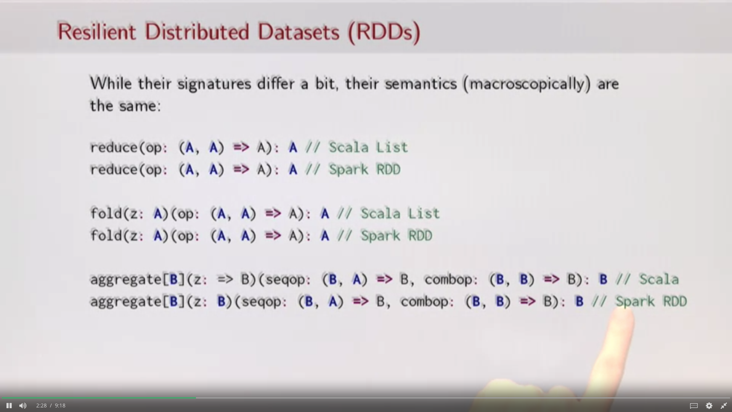

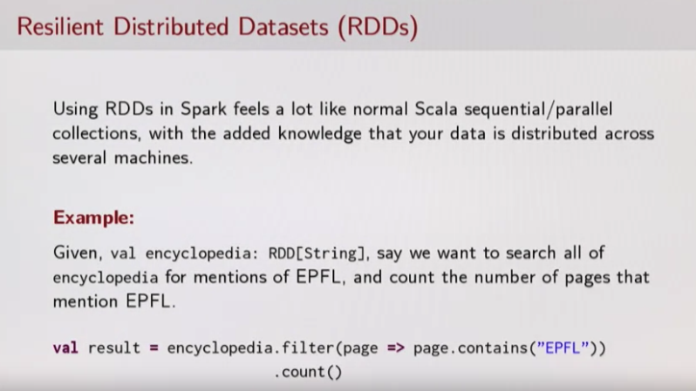

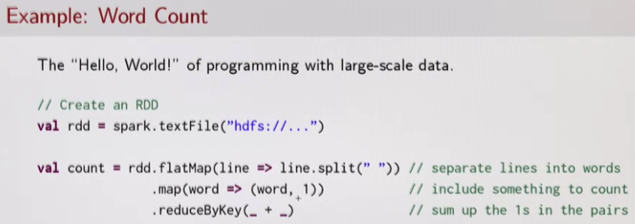

**How to create an RDD?**

* Transforming an existing RDD

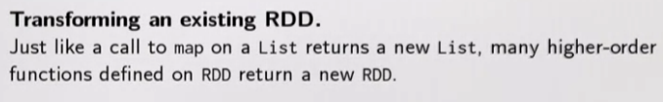

* From a SparkContext (or SparkSession) object

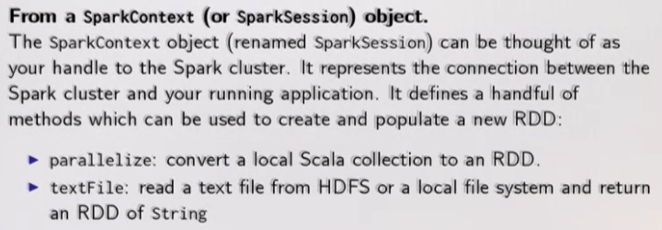

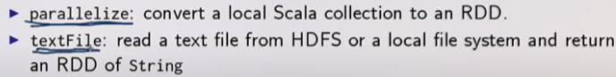

SparkContext is the handle to the cluster. whenever you start a new Spark job, you gotta create a SparkContext first. You gotta pass some parameters to it to configure your Spark job and then you've gotta start creating RDDs using this SparkContext

3.3